**Bytewise fellowship: Data Engineering**

**Task 6:**

**Creating and altering tables:**

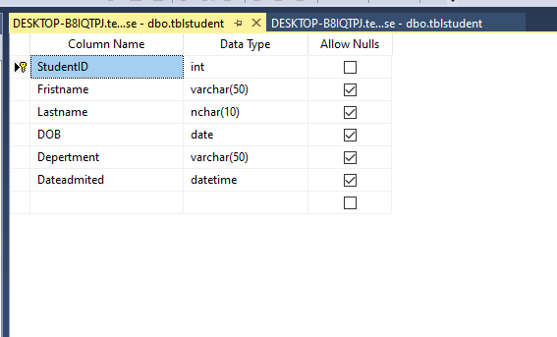

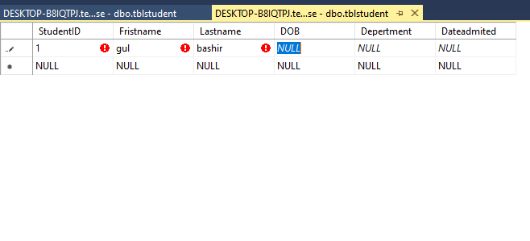

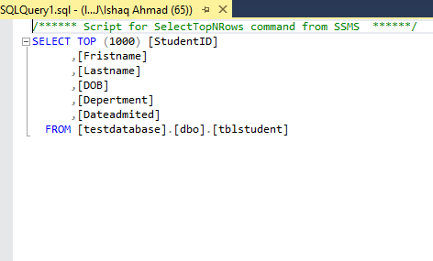

**Altering table is to add remove or delete something in the existing table.**